- Problem Statement-
Inconsistencies across government-issued IDs often go unnoticed due to manual errors, creating additional time, effort, and documentation hassles when users need to correct them later. The problem is to identify these mismatches early and help users maintain consistent information across their official documents.

- Goals and what are my non goals-
- Goals
1. Identify mismatches among different government-authorized ID cards to save users time and effort.
2. A centralised dashboard to collaborate and cross check with all the id cards to avoid manual error while filling new forms.
3. Provide timely alerts for required government/document-related actions.
- Non Goals
1. The platform will not function as a new government-issued ID.
2. Do not generate false or irrelevant mismatch alerts; notifications should be based on meaningful and actionable discrepancies.

- Success Metrics
North Star:
- Number of meaningful mismatches successfully identified and resolved by users.
- Reduction in average time and cost required to correct document mismatches.
- Number of B2B organizations adopting the platform for document-data verification.
Counter:
a. % of flagged mismatches that are later confirmed to be valid/harmless differences.

4.User Journey- Empathy Map
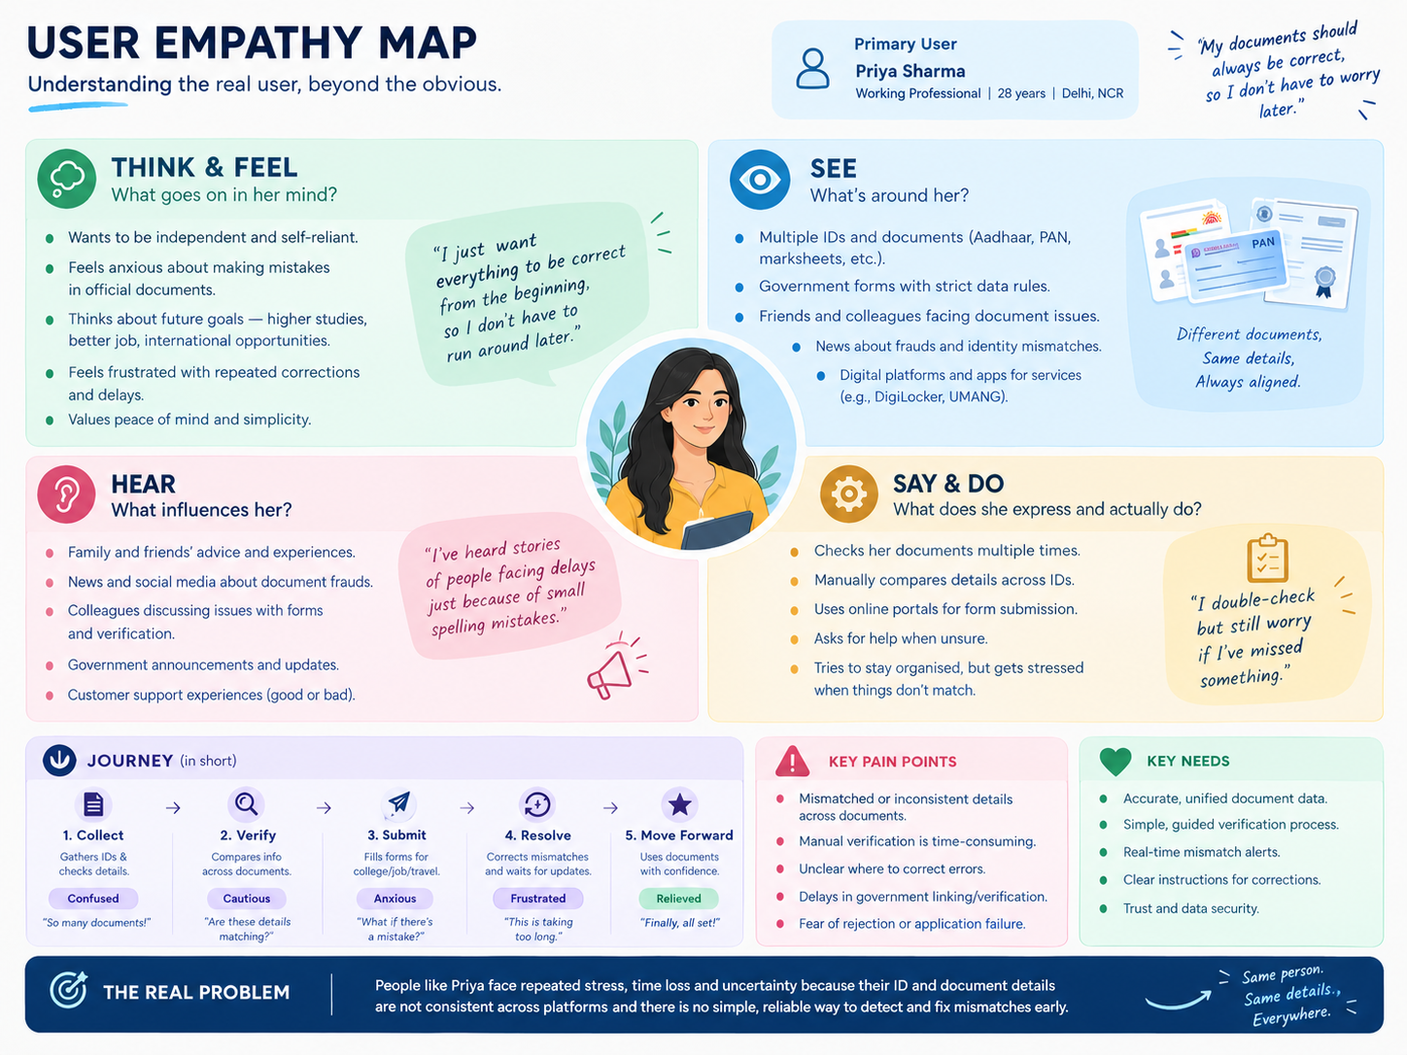

I want

5.What is the competitor offering

Cross-Document Consistency Check — Compare information across government-issued IDs and identify meaningful mismatches early.
Smart Mismatch Alerts & Correction Guidance — Prioritize important discrepancies and guide users toward the appropriate correction action.
Unified Document Dashboard — Bring verified documents and key information into one place for easy review and future form filling.

RICE Inspired Prioritization
Opportunity / Solution | Reach (R) | Impact (I) | Confidence (C) | Effort (E) | RICE Score
Cross-Document Consistency Check | High | High | Med | Mid | P0
Smart Mismatch Alerts & Correction Guidance | Mid | High | Mid | Low | P1
Unified Document Dashboard | High | Med | Mid | Mid | P2

6. Functional and Acceptance Criteria/ Non-Functional Requirement

Functional- The platform should allow users to upload or connect their government-issued IDs and use AI to extract, compare, and identify meaningful inconsistencies across key information such as name, date of birth, address, and other relevant fields. It should highlight important mismatches, explain their potential impact, and provide appropriate guidance for correction. Users should remain in control of reviewing and deciding whether to take corrective action.

Non functional requirement-
- P – Performance — Document processing and mismatch detection should be completed within an acceptable response time without disrupting the user experience.
- Q – Quality — Extracted information and mismatch detection should be accurate, relevant, and minimize false or irrelevant alerts.
- R – Reliability — Users should be able to revisit their documents, review previously identified mismatches, and re-check documents without losing their data or history.
- S – Security — Government-issued documents, personal information, and user data should be securely stored, processed, and protected.
- T – Transparency — The platform should clearly show which documents and fields were compared, what mismatch was identified, and why the mismatch may require attention.
- U – Usability — Users should be able to upload, compare, understand, and review their documents with minimal effort and without technical knowledge.
7. Mock Up: tool link https://stitch.google.com/projects/13315518883121921507?pli=1
8.Prototypes:
9.Github Push As A Portfolio:

